Test Case: tc002_SPX_Dev5_Crear_Requisicion_Spot_Con_FAD_Tipo_Cobro_CC
Step 1 - Enter username and password and click to button Enter : Credentials Entered
Image file-name: QC_Testing-tc002_SPX_Dev5_Crear_Requisicion_Spot_Con_FAD_Tipo_Cobro_CC-1790170067289

Step 2 - Select to UEN and Access to Spot Buy Requisitions : UEN Correctly selected and Correct access
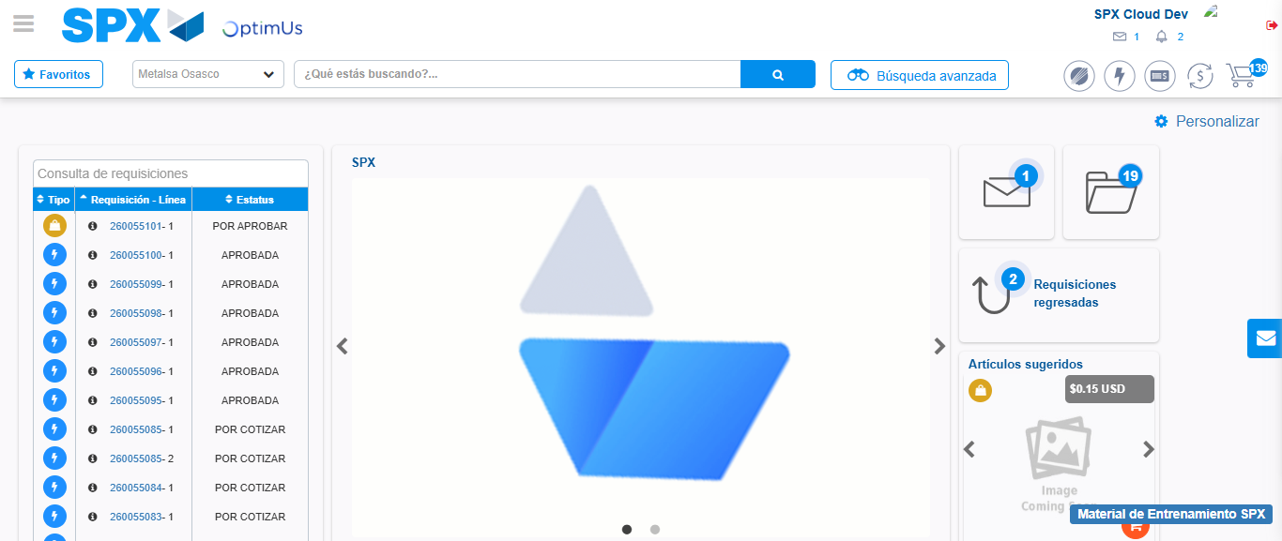Image file-name: QC_Testing-tc002_SPX_Dev5_Crear_Requisicion_Spot_Con_FAD_Tipo_Cobro_CC-1790170092216

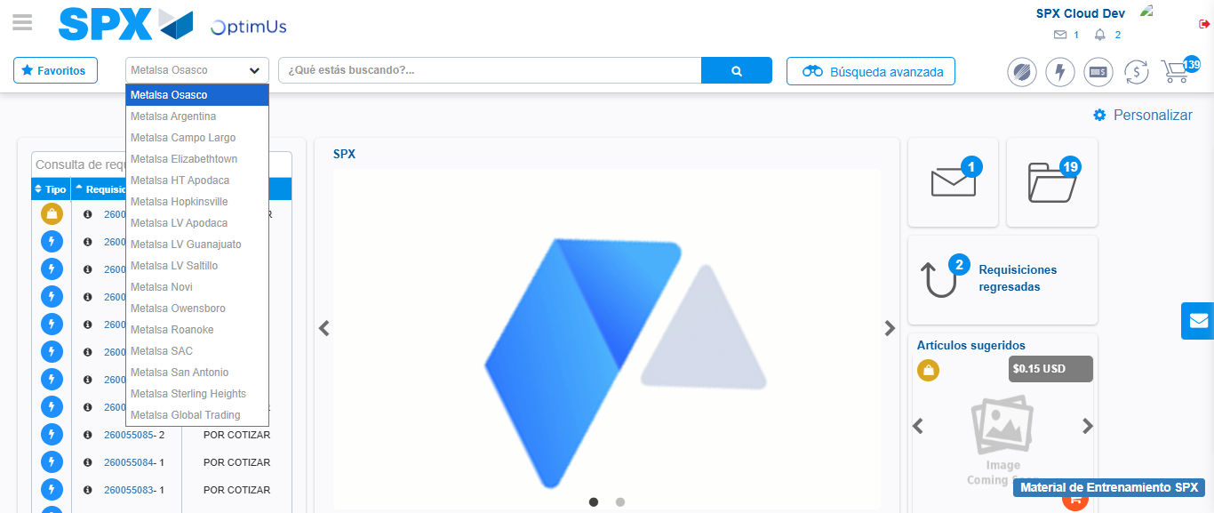Image file-name: QC_Testing-tc002_SPX_Dev5_Crear_Requisicion_Spot_Con_FAD_Tipo_Cobro_CC-1790170092893

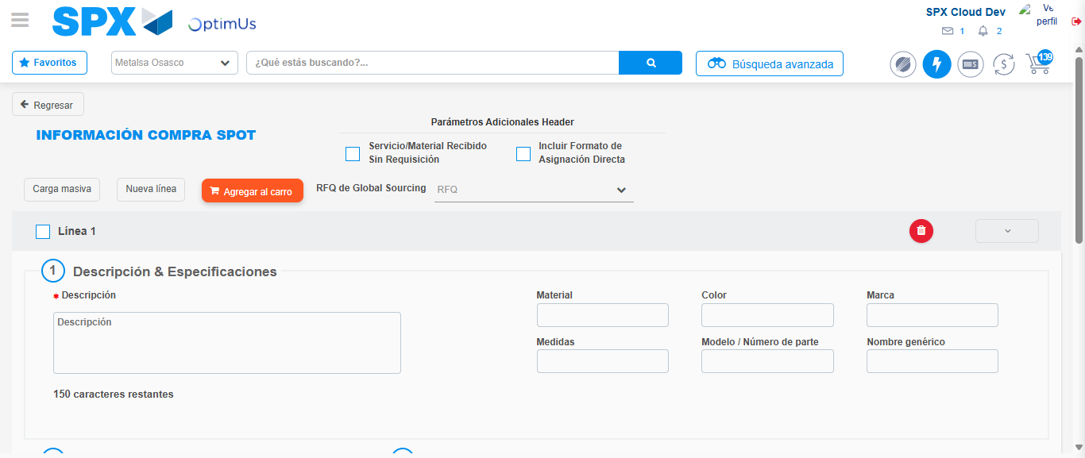Image file-name: QC_Testing-tc002_SPX_Dev5_Crear_Requisicion_Spot_Con_FAD_Tipo_Cobro_CC-1790170099022

Step 3 - Add FAD to Requisition: FAD Successfully Added
Image file-name: QC_Testing-tc002_SPX_Dev5_Crear_Requisicion_Spot_Con_FAD_Tipo_Cobro_CC-1790170099285

Image file-name: QC_Testing-tc002_SPX_Dev5_Crear_Requisicion_Spot_Con_FAD_Tipo_Cobro_CC-1790170099494

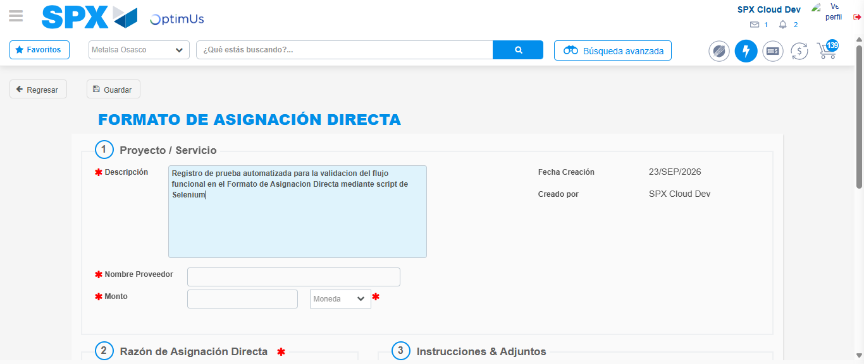Image file-name: QC_Testing-tc002_SPX_Dev5_Crear_Requisicion_Spot_Con_FAD_Tipo_Cobro_CC-1790170102347

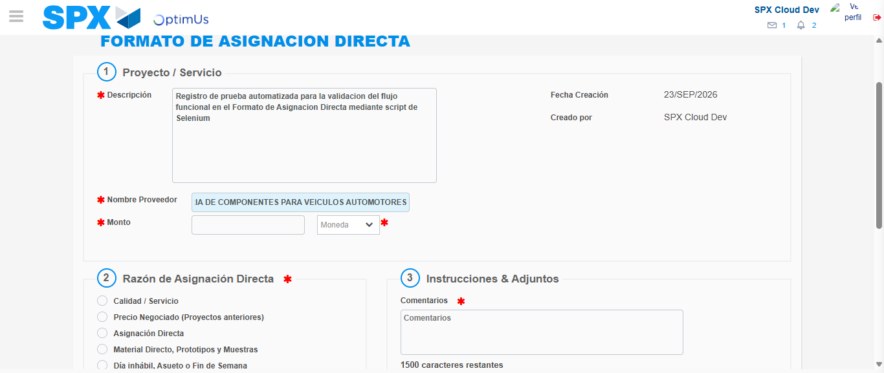Image file-name: QC_Testing-tc002_SPX_Dev5_Crear_Requisicion_Spot_Con_FAD_Tipo_Cobro_CC-1790170111330

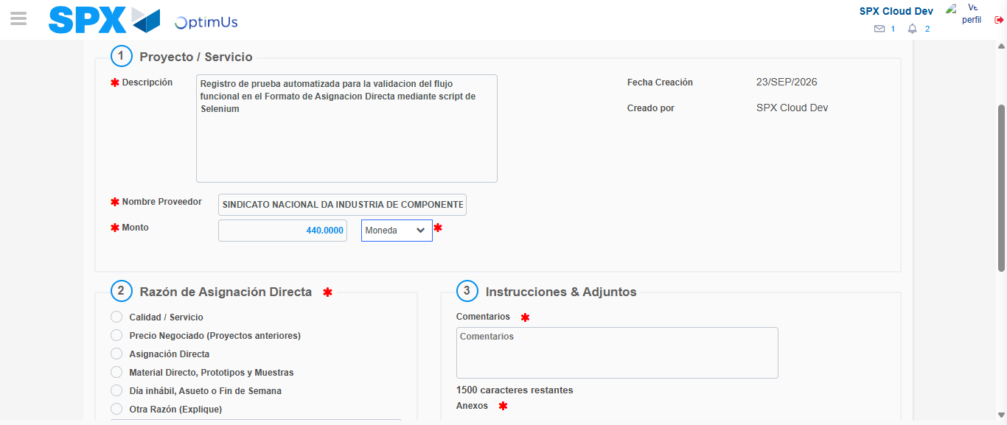Image file-name: QC_Testing-tc002_SPX_Dev5_Crear_Requisicion_Spot_Con_FAD_Tipo_Cobro_CC-1790170111787

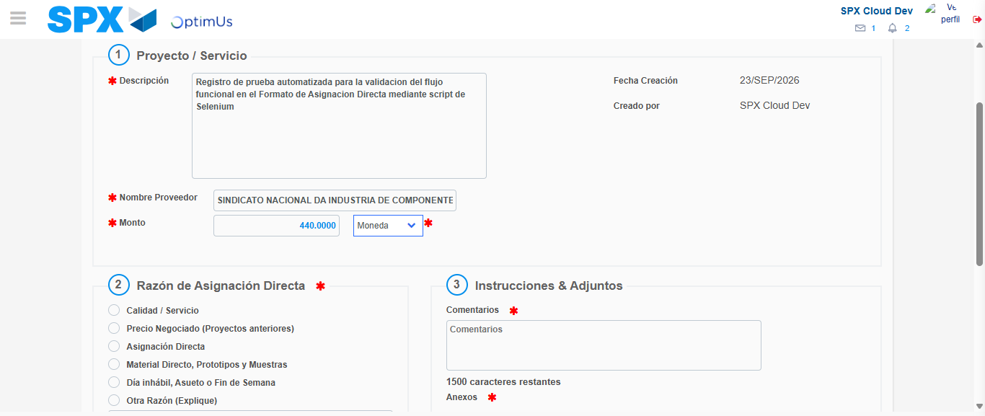Image file-name: QC_Testing-tc002_SPX_Dev5_Crear_Requisicion_Spot_Con_FAD_Tipo_Cobro_CC-1790170112063

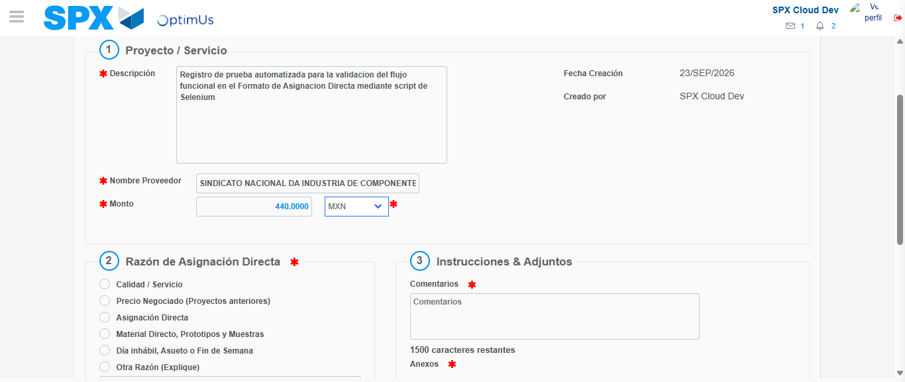Image file-name: QC_Testing-tc002_SPX_Dev5_Crear_Requisicion_Spot_Con_FAD_Tipo_Cobro_CC-1790170112478

Image file-name: QC_Testing-tc002_SPX_Dev5_Crear_Requisicion_Spot_Con_FAD_Tipo_Cobro_CC-1790170112702

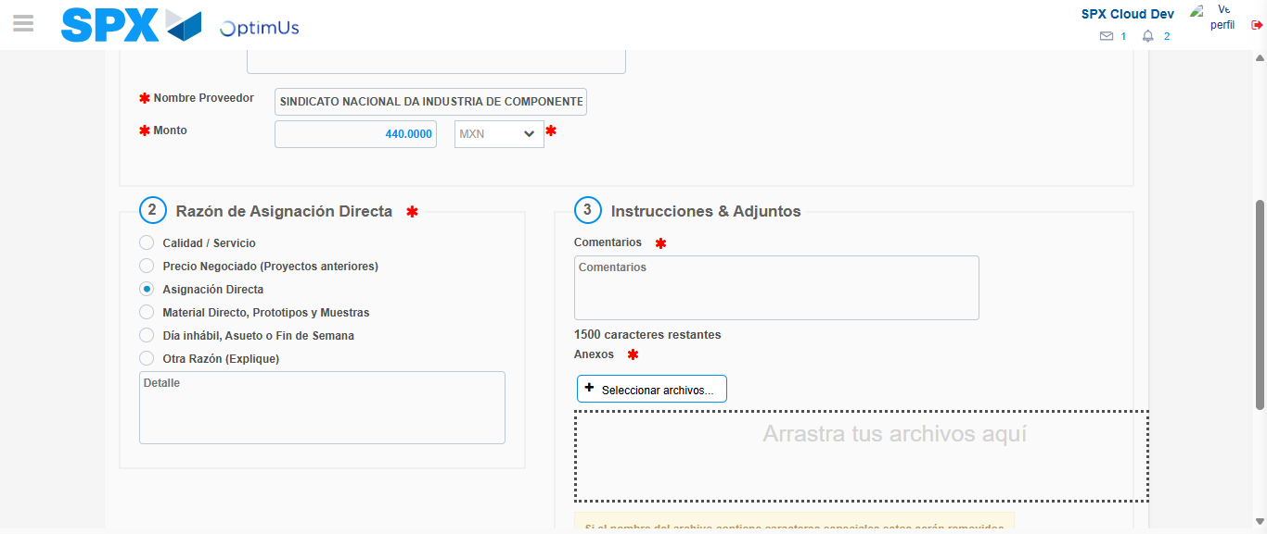Image file-name: QC_Testing-tc002_SPX_Dev5_Crear_Requisicion_Spot_Con_FAD_Tipo_Cobro_CC-1790170113531

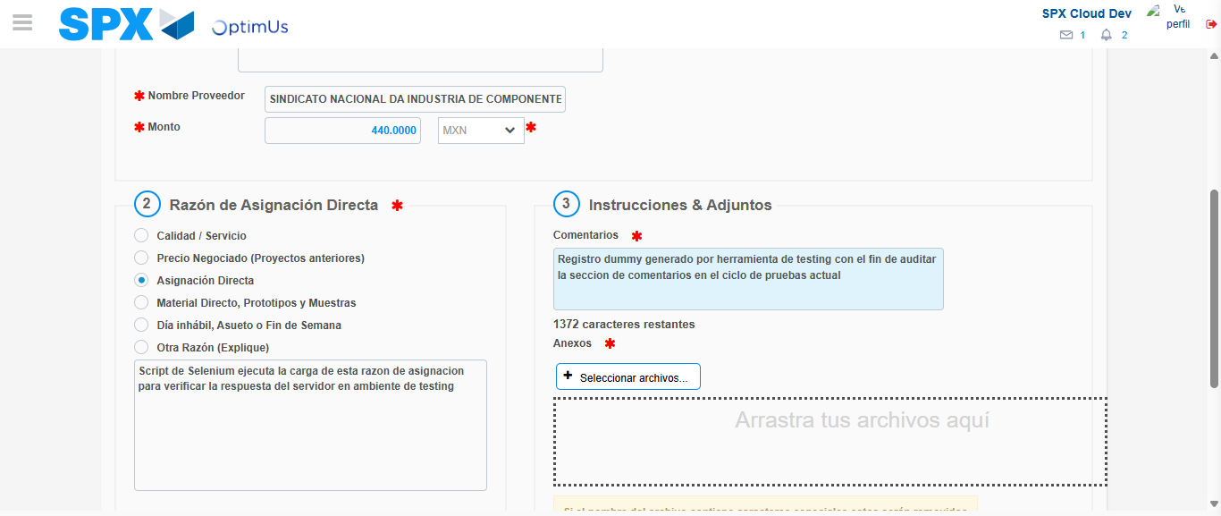Image file-name: QC_Testing-tc002_SPX_Dev5_Crear_Requisicion_Spot_Con_FAD_Tipo_Cobro_CC-1790170124657

Image file-name: QC_Testing-tc002_SPX_Dev5_Crear_Requisicion_Spot_Con_FAD_Tipo_Cobro_CC-1790170125322

Step 4 - Data Capture Spot Buy Requisition: Data captured correctly
Image file-name: QC_Testing-tc002_SPX_Dev5_Crear_Requisicion_Spot_Con_FAD_Tipo_Cobro_CC-1790170099285

Image file-name: QC_Testing-tc002_SPX_Dev5_Crear_Requisicion_Spot_Con_FAD_Tipo_Cobro_CC-1790170099494

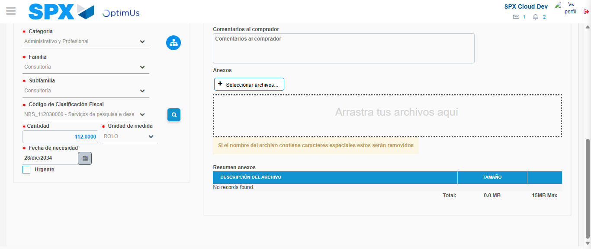Image file-name: QC_Testing-tc002_SPX_Dev5_Crear_Requisicion_Spot_Con_FAD_Tipo_Cobro_CC-1790170150343

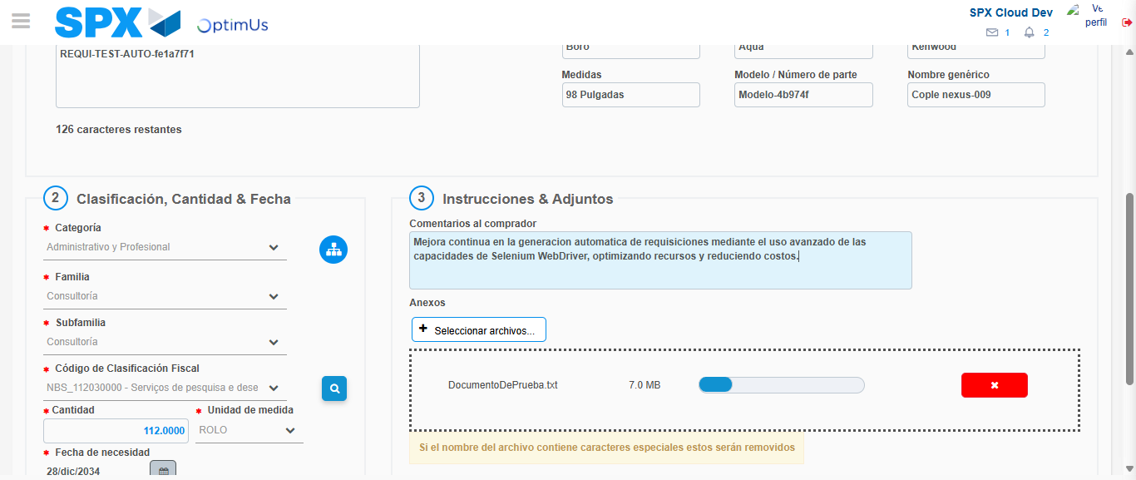Image file-name: QC_Testing-tc002_SPX_Dev5_Crear_Requisicion_Spot_Con_FAD_Tipo_Cobro_CC-1790170151203

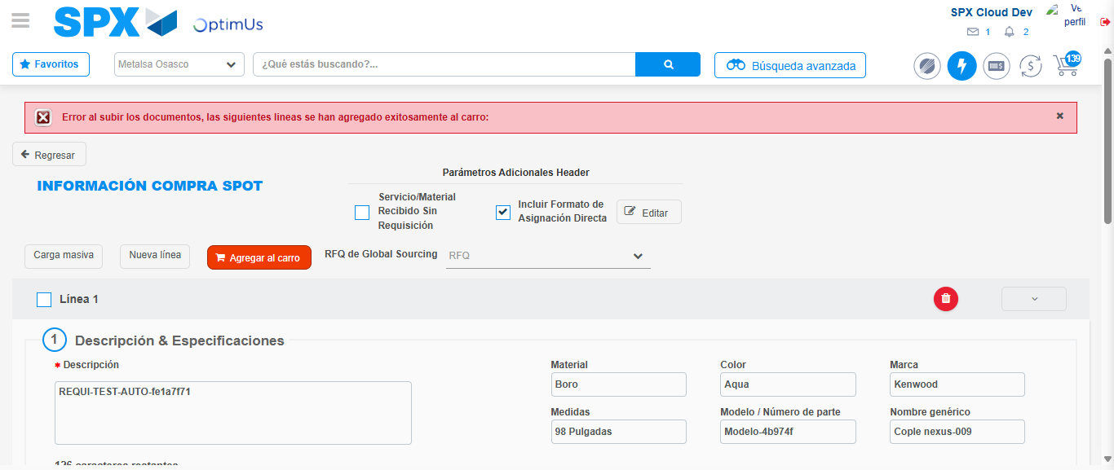Image file-name: QC_Testing-tc002_SPX_Dev5_Crear_Requisicion_Spot_Con_FAD_Tipo_Cobro_CC-1790170165266

Step 8 - Return to Main Page SPX : Return to Main Page SPX
Image file-name: QC_Testing-tc002_SPX_Dev5_Crear_Requisicion_Spot_Con_FAD_Tipo_Cobro_CC-1790170092216

Image file-name: QC_Testing-tc002_SPX_Dev5_Crear_Requisicion_Spot_Con_FAD_Tipo_Cobro_CC-1790170092893

Image file-name: QC_Testing-tc002_SPX_Dev5_Crear_Requisicion_Spot_Con_FAD_Tipo_Cobro_CC-1790170099022

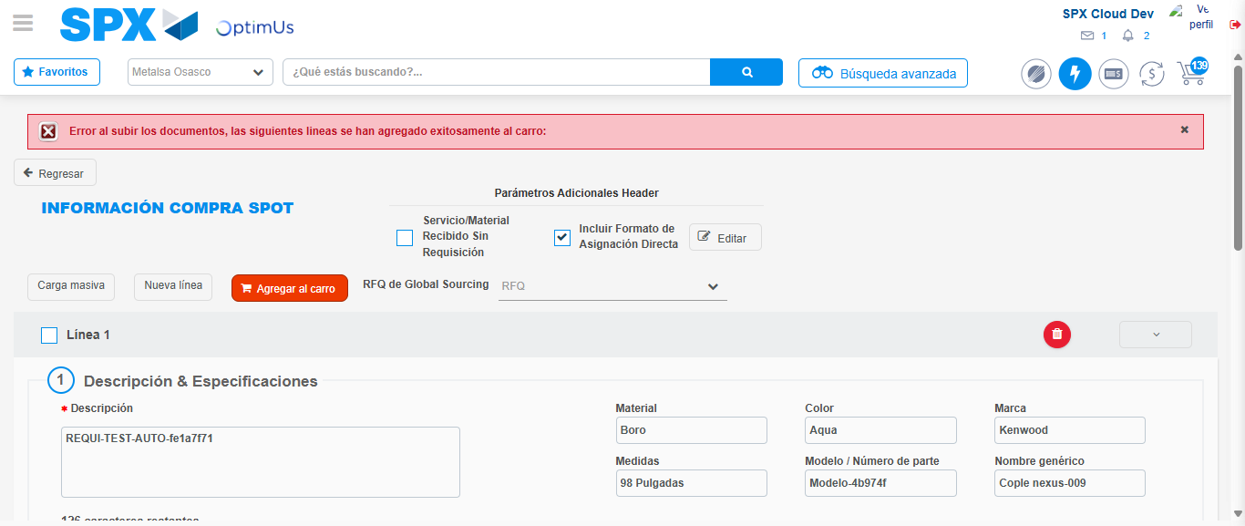Image file-name: QC_Testing-tc002_SPX_Dev5_Crear_Requisicion_Spot_Con_FAD_Tipo_Cobro_CC-1790170167575

Image file-name: QC_Testing-tc002_SPX_Dev5_Crear_Requisicion_Spot_Con_FAD_Tipo_Cobro_CC-1790170167800

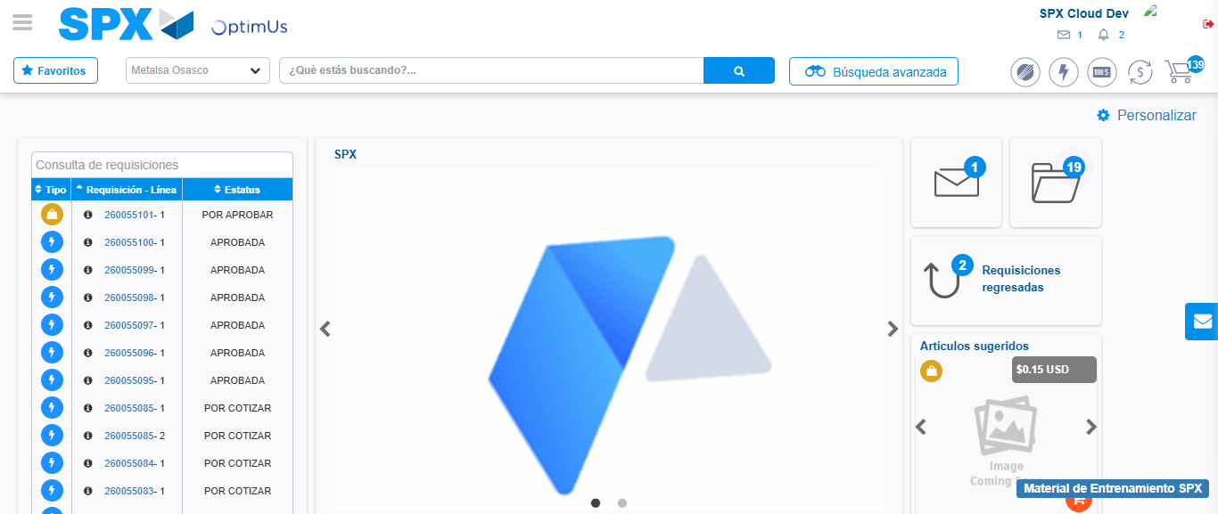Image file-name: QC_Testing-tc002_SPX_Dev5_Crear_Requisicion_Spot_Con_FAD_Tipo_Cobro_CC-1790170189212

Step 9 - Log Out : Log Out SPX
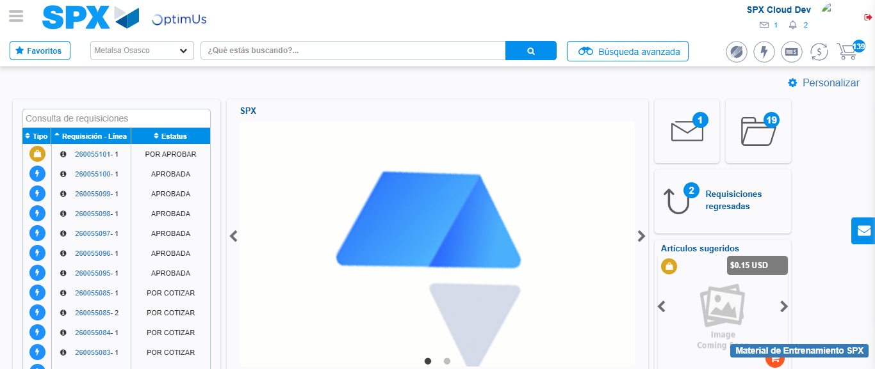Image file-name: QC_Testing-tc002_SPX_Dev5_Crear_Requisicion_Spot_Con_FAD_Tipo_Cobro_CC-1790170189566

